# Post

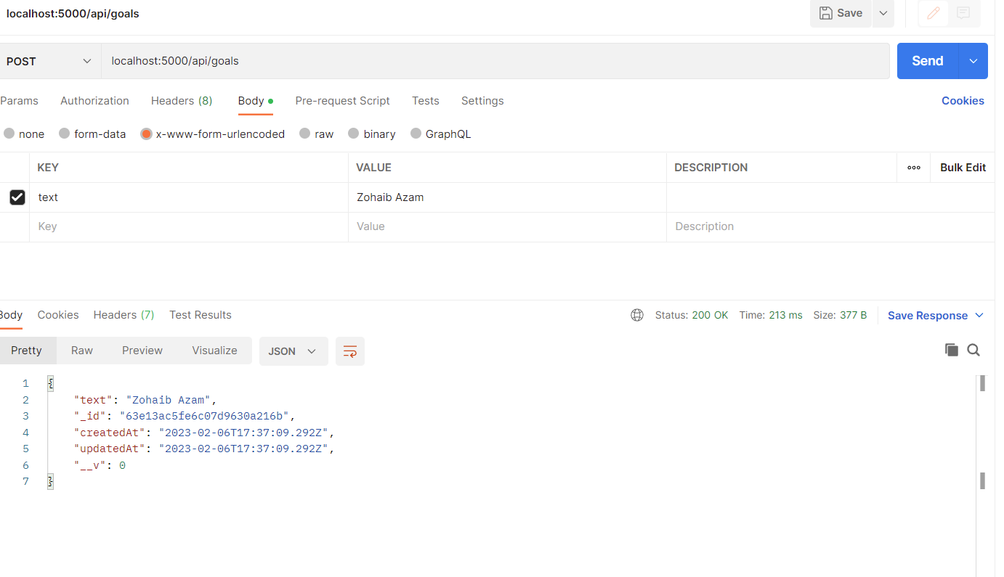

# Get

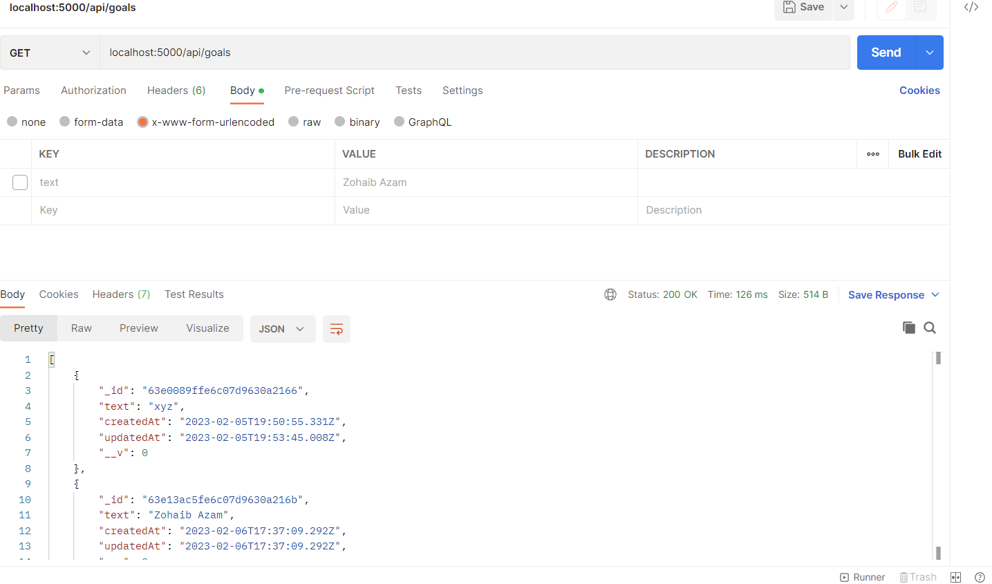

# Put

Select the id of any document shown above and update its text field.

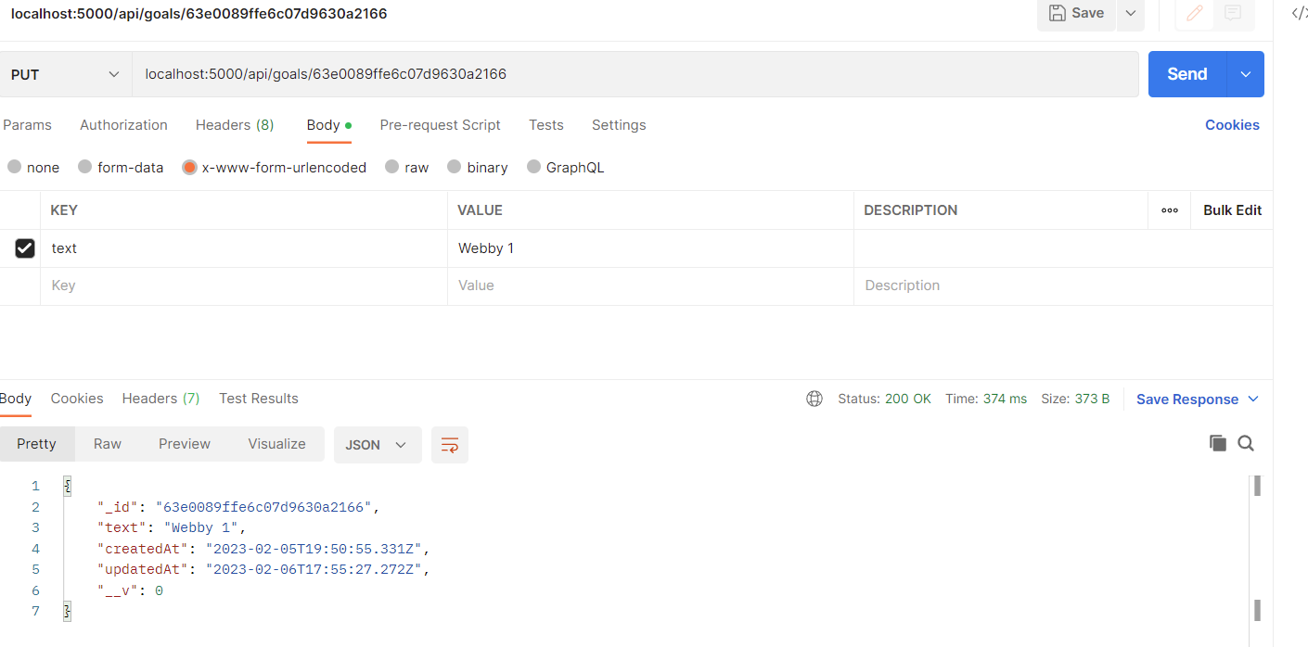

Now if we will fetch/GET we would get Webby 1 instead of XYZ as we updated XYZ’s document

# Delete

Write id of a document to remove it. Deleting webby 1 using its ID:

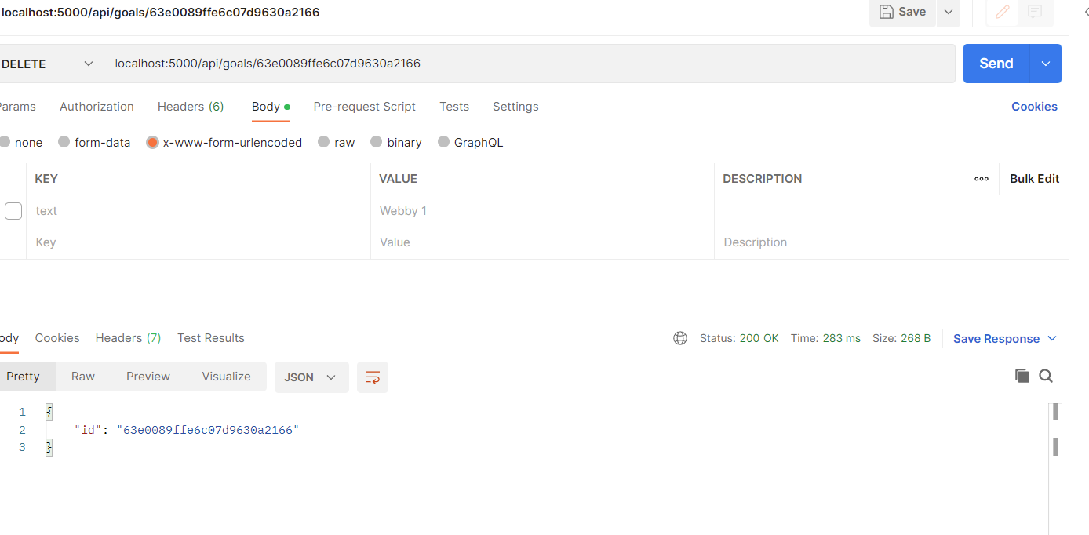

Now when we will fetch the data, webby 1 should be deleted

